-- Pull the number of transactions by store country

select t.transaction_date, s.store_country,

COUNT(t.transaction_date) OVER() AS total_number_of_transctions,

COUNT(t.transaction_date) OVER(PARTITION BY s.store_country) AS number_of_transactions_by_store_country

from Transaction_Data t

left join Stores s on s.store_id = t.store_id

-- Pull the weekly revenue trending

select SUM(t.revenue) AS weekly_revenue, DATETRUNC(WEEK, c.Date) AS start_of_week from Transaction_Data t

inner join Calendar c on c.date = t.transaction_date

group by DATETRUNC(WEEK, c.Date)

-- Pull the top 10 product brands in terms of number of Transactions and Revenue

select top 10

p.product_brand, COUNT(t.transaction_date) AS count_of_transactions, SUM(t.revenue) AS total_revenue from Transaction_Data t

inner join products p on p.product_id = t.product_id

group by p.product_brand

order by SUM(t.revenue) DESC

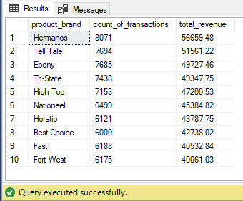

-- Bonus question Rank the total revenue and total transactions by product brand

WITH CTE AS

(select p.product_brand, SUM(t.revenue) AS total_revenue, COUNT(t.transaction_date) AS count_of_transactions,

RANK() OVER(ORDER BY SUM(t.revenue) DESC) AS total_revenue_ranked,

RANK() OVER(ORDER BY COUNT(t.transaction_date) DESC) AS total_transactions_ranked

from Transaction_Data t

inner join products p on p.product_id = t.product_id

group by p.product_brand)

select * from CTE where (total_revenue_ranked >= 1 and total_revenue_ranked <=10)

AND (total_transactions_ranked >=1 and total_transactions_ranked <=10)

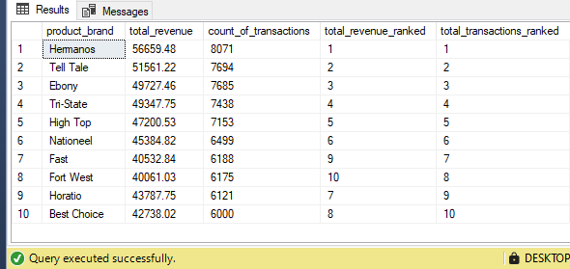

-- Pull the weekly number of customer

select count(distinct customer_id) AS number_of_customers, DATETRUNC(week, c.date) as start_of_week from Transaction_Data t

left join Calendar c on t.transaction_date = c.Date

group by DATETRUNC(week, c.date)

order by DATETRUNC(week, c.date) asc

-- Pull the number of transactions by education excluding the bachelors degree

select count(t.transaction_date) as number_of_transactions, c.education from Transaction_Data t

inner join Customers c on c.customer_id = t.customer_id

where education != 'Bachelors Degree'

group by c.education

-- Additional Question Report the number of transactions in each country broken down by education level (transposing data)

select customer_country,

count(case when education = 'Partial High School' then t.transaction_date else null end) as 'partial high school transactions',

count(case when education = 'Partial College' then t.transaction_date else null end) as 'partial college transactions',

count(case when education = 'Graduate Degree' then t.transaction_date else null end) as 'Graduate Degree transactions',

count(case when education = 'High School Degree' then t.transaction_date else null end) as 'High School Degree transactions'

from Transaction_Data t

inner join Customers c on c.customer_id = t.customer_id

group by customer_country

-- Show the top 3 occupations in terms of number of transactions excluding customers with a bachelors degree

select TOP 3

count(t.transaction_date) as number_of_transactions, c.occupation

from Transaction_Data t

inner join Customers c on c.customer_id = t.customer_id

where c.education != 'Bachelors Degree'

group by c.occupation

order by number_of_transactions desc

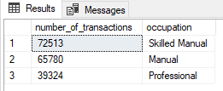

-- Using RANKING

WITH CTE AS (select c.occupation, count(t.transaction_date) as total_number_of_transactions,

RANK() OVER(ORDER BY count(t.transaction_date) desc) AS ranking

from Transaction_Data t

inner join Customers c on c.customer_id = t.customer_id

where c.education != 'Bachelors Degree'

group by c.occupation)

select * from CTE

where ranking between 1 and 3

-- Optional Question. Let's rank customers within each occupation based on their number of transactions.

-- Which customer_id has the highest volume of transactions for each occupation?

WITH CTE AS

(select c.customer_id, c.occupation, count(t.transaction_date) as 'number of transactions',

RANK() OVER(PARTITION BY c.occupation ORDER BY COUNT(t.transaction_date) desc) as ranking,

ROW_NUMBER() OVER(PARTITION BY c.occupation ORDER BY COUNT(t.transaction_date) desc) as r_n

from Transaction_Data t

inner join Customers c on c.customer_id = t.customer_id

group by c.customer_id, c.occupation)

select * from CTE

where r_n = 1

-- Pull total number of transactions, revenue grouped by customer id and full_name. Filter and rank 100 top customers by number of transactions

select TOP 100 c.customer_id, CONCAT_WS(' ', c.first_name, c.last_name) AS 'full name',

COUNT(t.transaction_date) AS 'number of transactions', SUM(t.revenue) AS 'total revenue',

RANK() OVER(ORDER BY COUNT(t.transaction_date) DESC) as ranking

from Transaction_Data t

inner join Customers c on c.customer_id = t.customer_id

group by c.customer_id, CONCAT_WS(' ', c.first_name, c.last_name)

order by COUNT(t.transaction_date) DESC

-- Which customer drove the highest revenue? Report its number of transactions too

WITH CTE AS

(select c.customer_id, c.full_name, SUM(t.revenue) as 'total revenue', COUNT(t.transaction_date) as 'count of transactions',

RANK() OVER(ORDER BY SUM(t.revenue) DESC) AS ranking

from Transaction_Data t

inner join Customers c on c.customer_id = t.customer_id

group by c.customer_id, c.full_name)

SELECT * FROM CTE WHERE ranking = 1



-- Total Revenue & Profit Trending

select SUM(t.quantity * p.product_retail_price) AS Total_revenue,

SUM(t.revenue - t.COGS) AS Total_profit,

DATEPART(YEAR, c.date) AS year,

DATETRUNC(MONTH, c.Date) AS start_of_month,

DATEPART(QUARTER, c.date) AS quarter,

DATETRUNC(WEEK, c.Date) AS start_of_week

from Transaction_Data t

inner join calendar c on c.Date = t.transaction_date

inner join products p on p.product_id = t.product_id

group by DATEPART(YEAR, c.date), DATETRUNC(MONTH, c.Date), DATEPART(QUARTER, c.date), DATETRUNC(WEEK, c.Date)

-- Additional Question. Calculate total revenue relating to product name 'High Top Garlic' and 'Tri State Red Pepper' for each year

select DATEPART(YEAR, c.Date) AS year,

SUM(CASE WHEN p.product_name = 'High Top Garlic' THEN revenue ELSE NULL END) AS total_revenue_HighTopGarlic,

SUM(CASE WHEN p.product_name = 'Tri-State Sweet Onion' THEN revenue ELSE NULL END) AS total_revenue_TriStateSweetOnion

from Transaction_Data t

inner join products p on p.product_id = t.product_id

inner join Calendar c on c.Date = t.transaction_date

group by DATEPART(YEAR, c.Date)

